- S3 web hosting

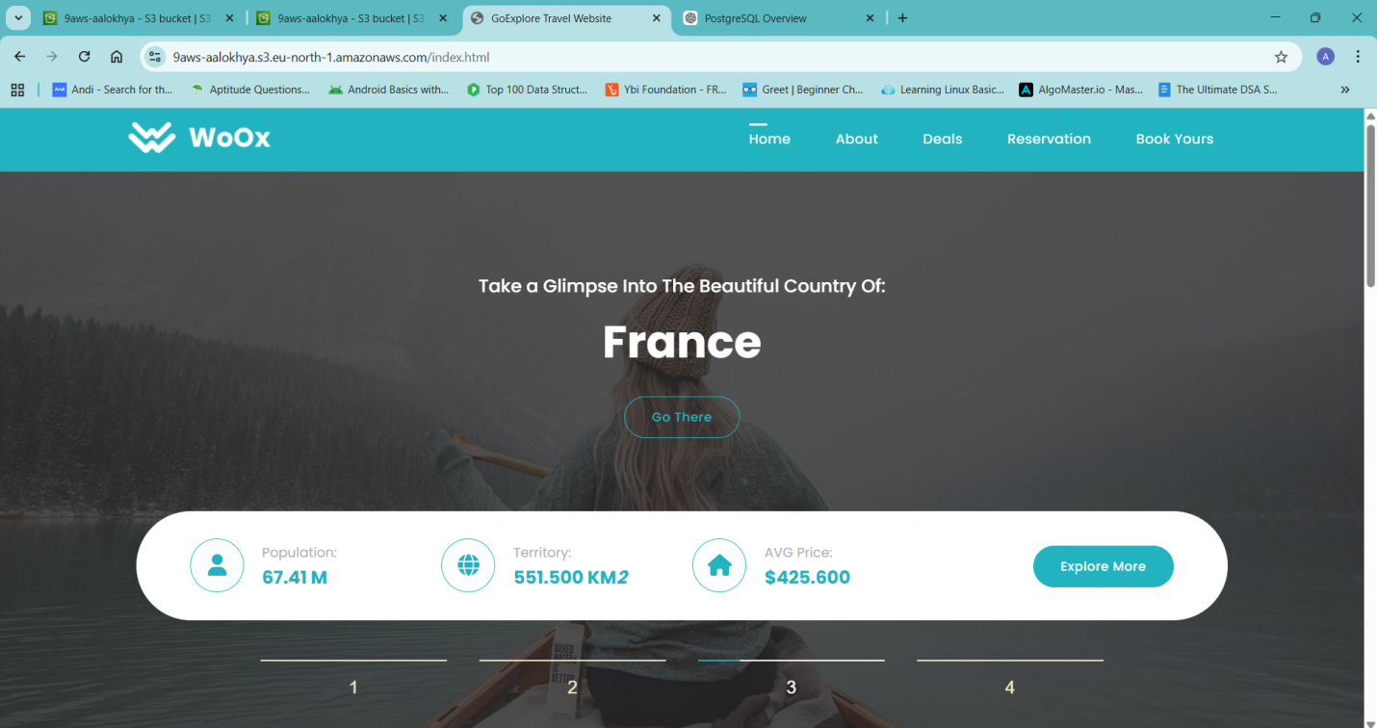

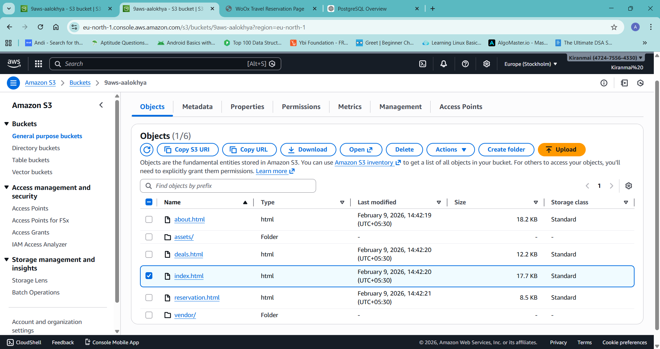

- Ec2 to s3 connection
1. Listing Directory Contents
Command:
Bash
ls
Usage: Lists the files and directories in your current local folder.
Context: Used at the start to check if the directory was empty and later to verify that files (hello.txt, index.txt) were created or downloaded successfully.
2. Listing S3 Buckets
Command:
Bash
aws s3 ls
Usage: Lists all S3 buckets available to your AWS account.
Output: In the example, it revealed the bucket named ec2cunnectbucket.
3. Creating a File (Linux)
Command:
Bash
touch hello.txt
Usage: Creates a new, empty file named hello.txt.
Context: This was used to create a test file locally before attempting to upload it to the cloud.
4. Downloading from S3 (Copy S3 → Local)
The cp command stands for "copy". It requires two arguments: a Source and a Destination.
Command:
Bash
aws s3 cp s3://ec2cunnectbucket/index.txt ./index.txt
Usage: Copies a file from an S3 bucket to your local machine.

Syntax Breakdown:
aws s3 cp: The operation (Copy).
s3://ec2cunnectbucket/index.txt: The Source (Where the file is now).
./index.txt: The Destination (Where you want to put it. ./ represents the current directory).
Note: In the log, previous attempts failed because the Destination argument was missing. You must always specify where the file should go.
5. Uploading to S3 (Copy Local → S3)
Command:
Bash
aws s3 cp hello.txt s3://ec2cunnectbucket
Usage: Copies a file from your local machine to an S3 bucket.
Syntax Breakdown:
hello.txt: The Source (The local file).
s3://ec2cunnectbucket: The Destination (The S3 bucket).

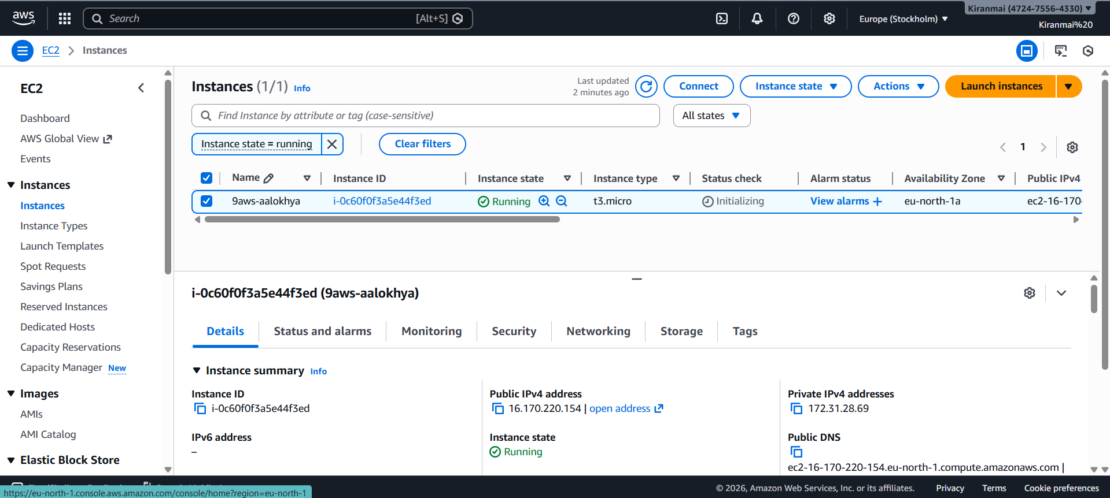

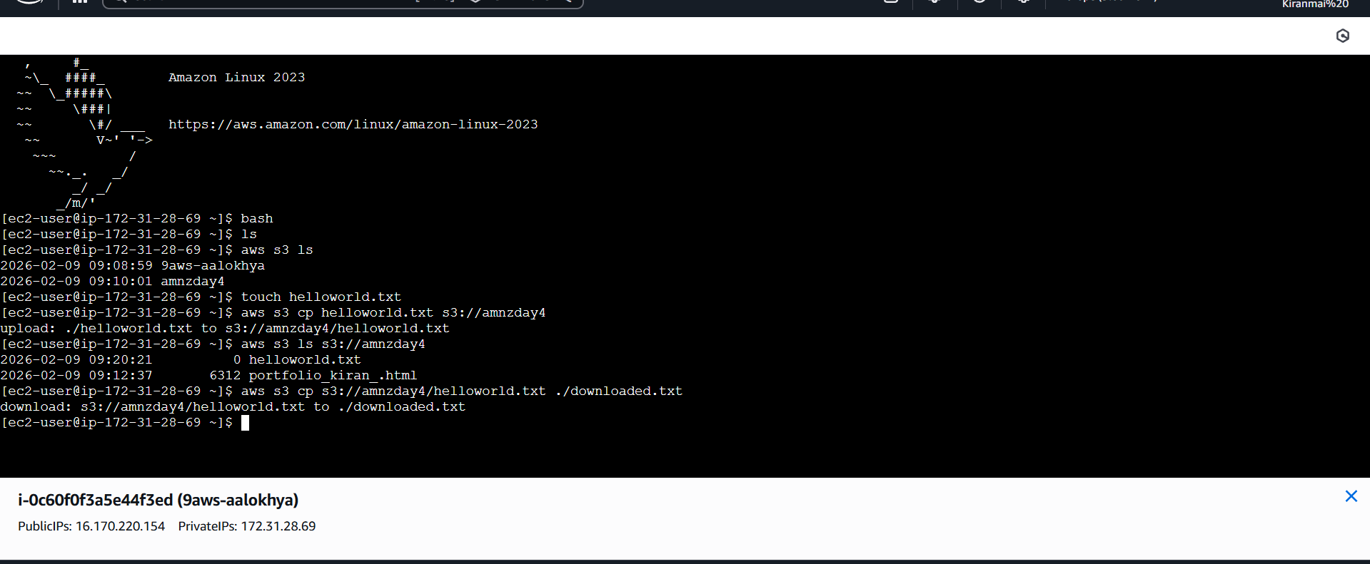

3.Web hosting ec2

Amazon Linux 2023
[ec2-user@ip-172-31-33-95 ~]$ sudo su
[root@ip-172-31-33-95 ec2-user]# yum update -y

[root@ip-172-31-33-95 ec2-user]#
[root@ip-172-31-33-95 ec2-user]# yum install -y httpd
[root@ip-172-31-33-95 ec2-user]# yum install -y unzip
[root@ip-172-31-33-95 ec2-user]# systemctl start httpd
[root@ip-172-31-33-95 ec2-user]# systemctl enable httpd
[root@ip-172-31-33-95 ec2-user]# systemctl status httpd

[root@ip-172-31-33-95 ec2-user]# cd /var/www/html
[root@ip-172-31-33-95 html]# wget https://github.com/aalokhya/aws_Training/archive/refs/heads/main.zip

[root@ip-172-31-33-95 html]# unzip main.zip
[root@ip-172-31-33-95 html]# cp -r aws_Training-main/* /var/www/html/
[root@ip-172-31-33-95 html]# systemctl restart httpd
[root@ip-172-31-33-95 html]# curl localhost

[root@ip-172-31-33-95 html]# systemctl status firewalld
Unit firewalld.service could not be found.
[root@ip-172-31-33-95 html]# systemctl status firewalld
Unit firewalld.service could not be found.
[root@ip-172-31-33-95 html]# curl 13.53.129.153

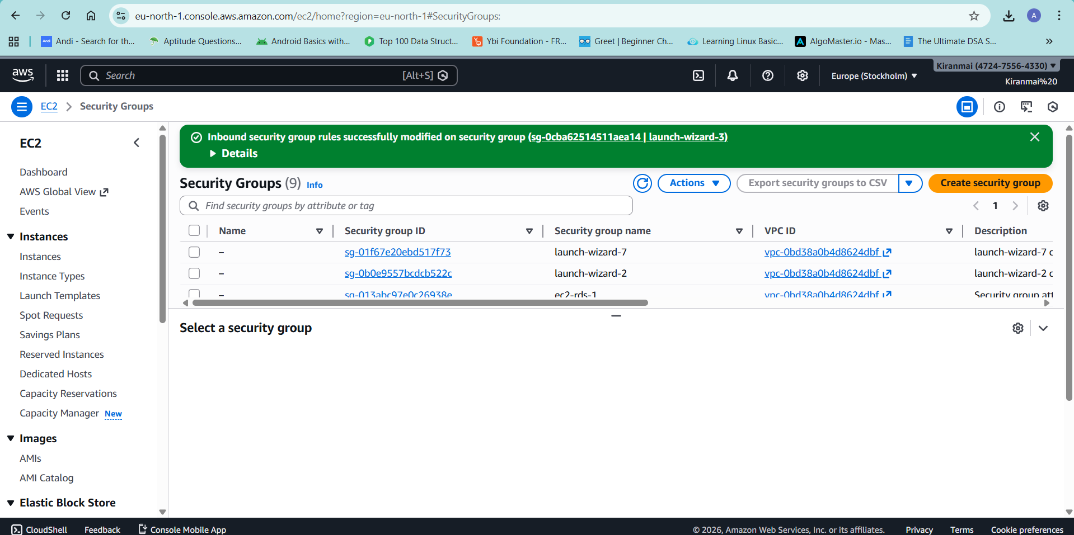
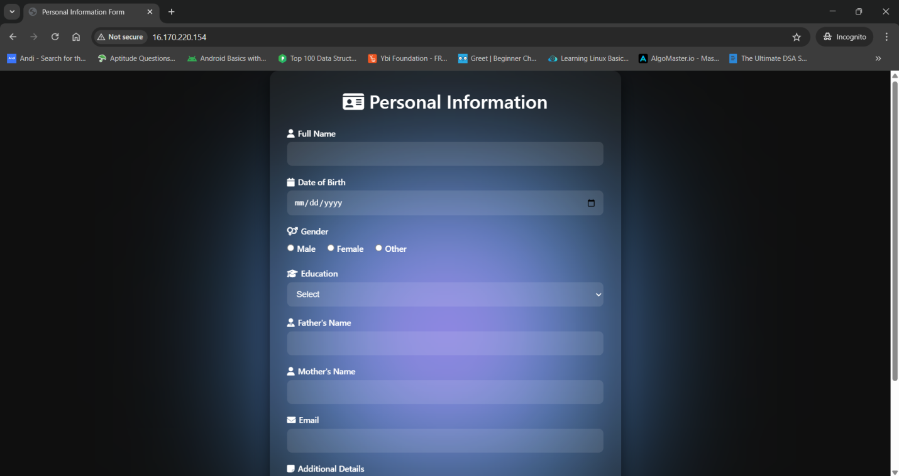

http://16.170.220.154

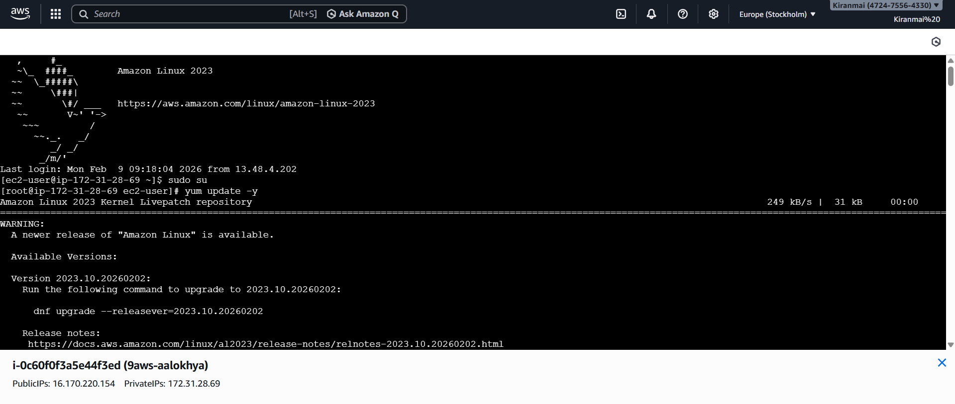

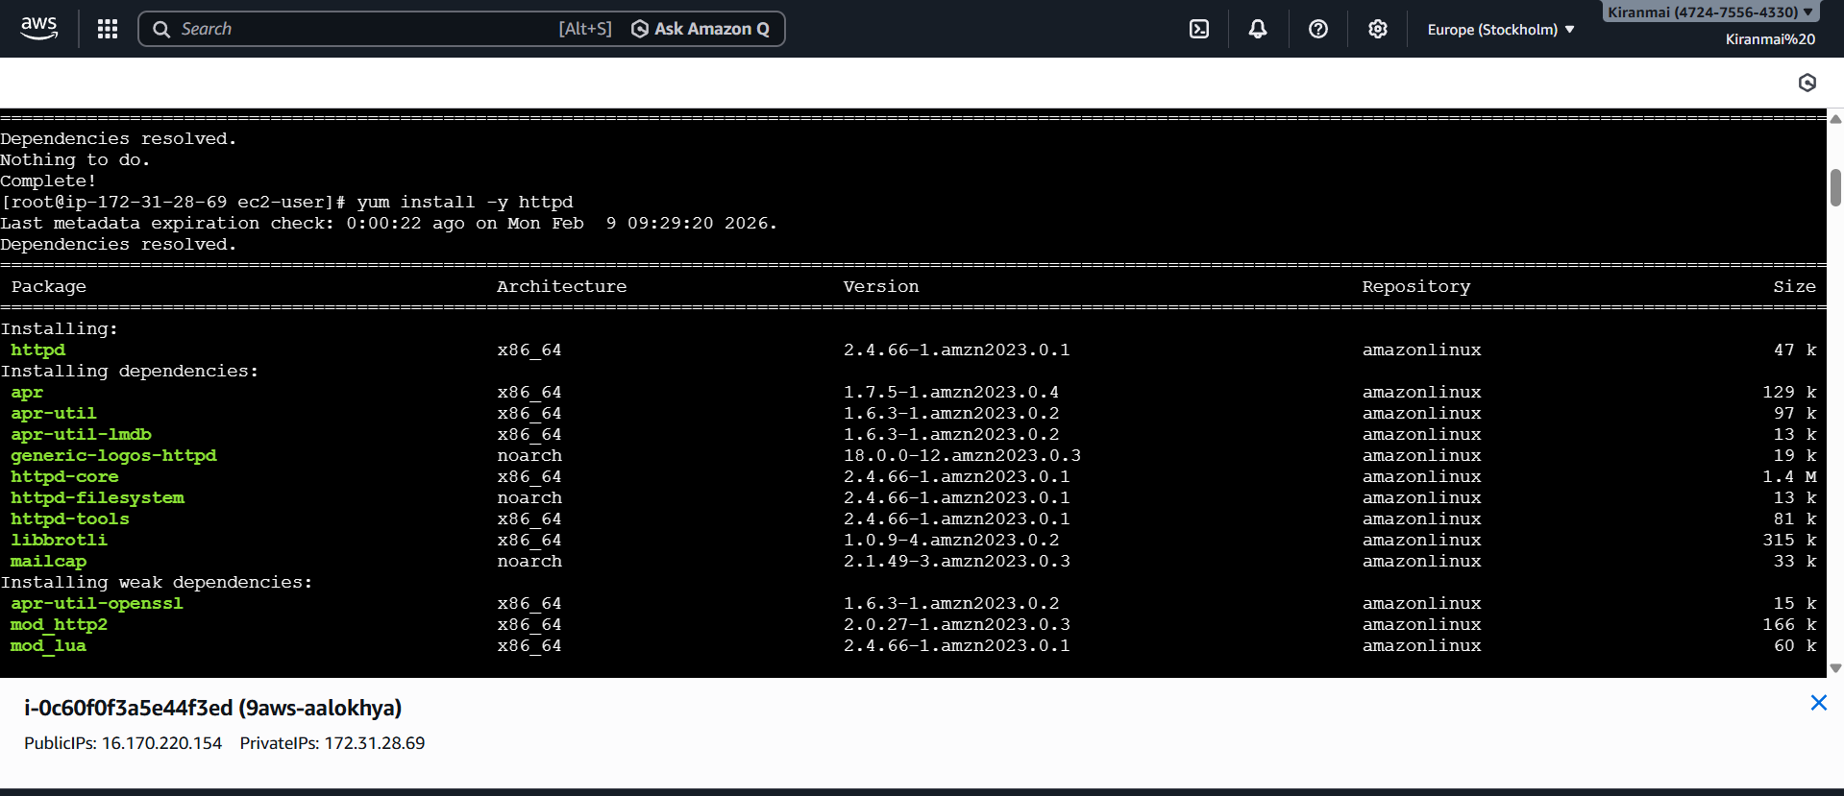

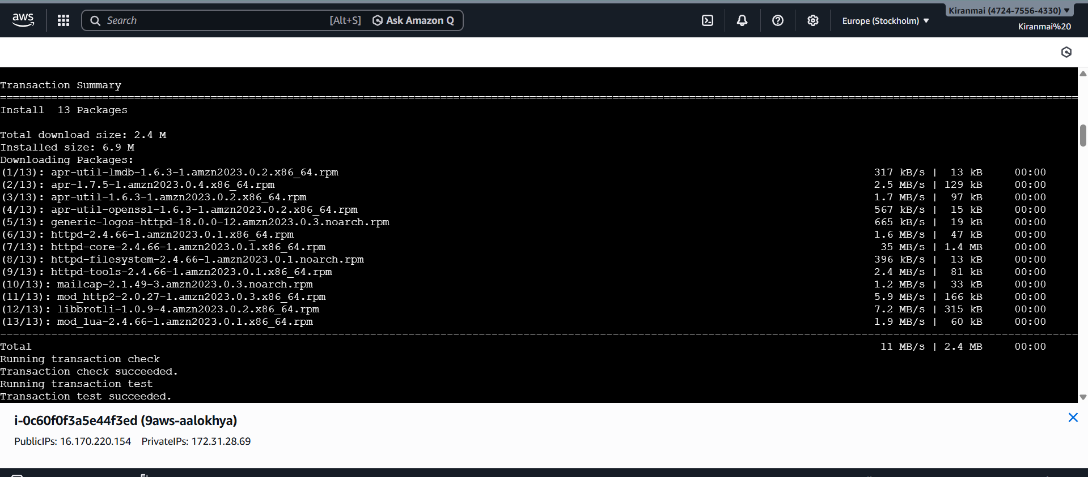

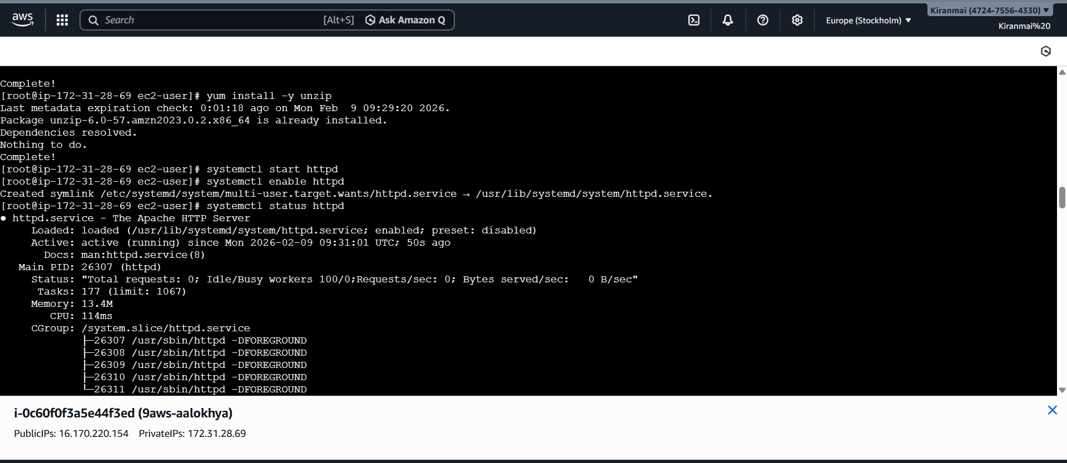

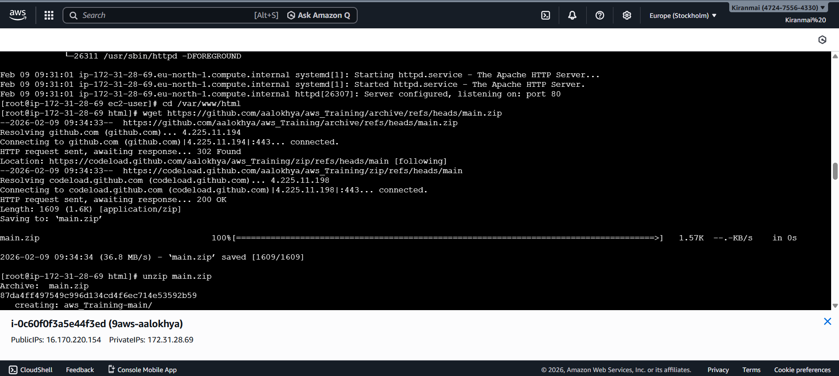

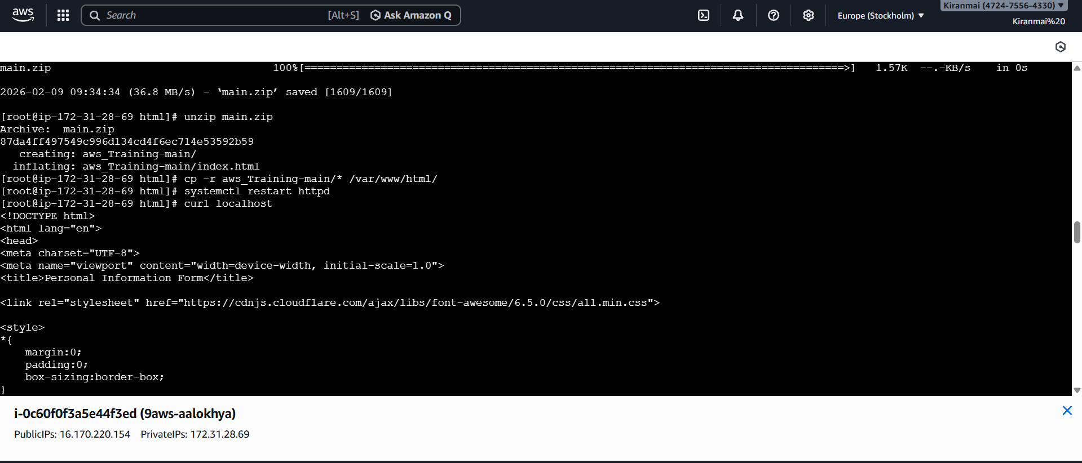

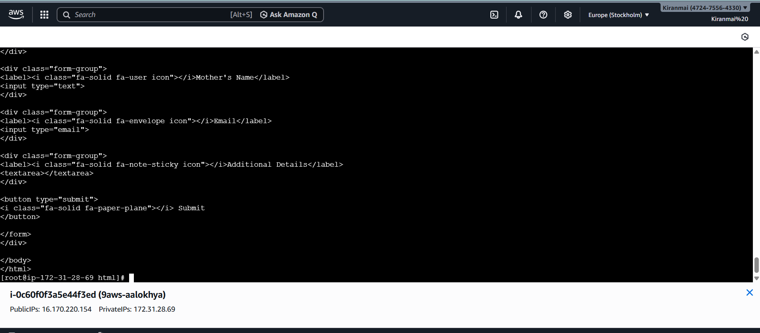

4.rds connection

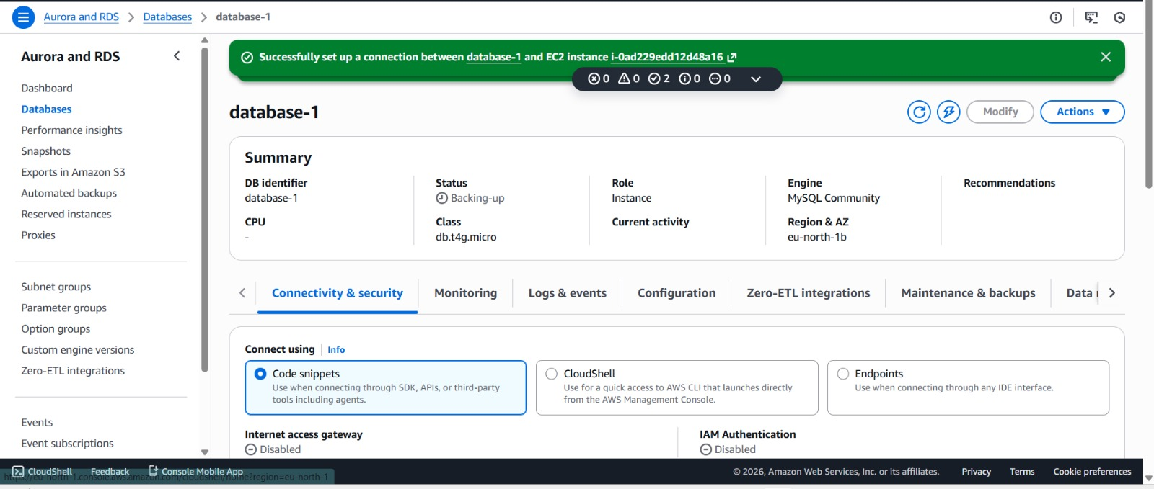

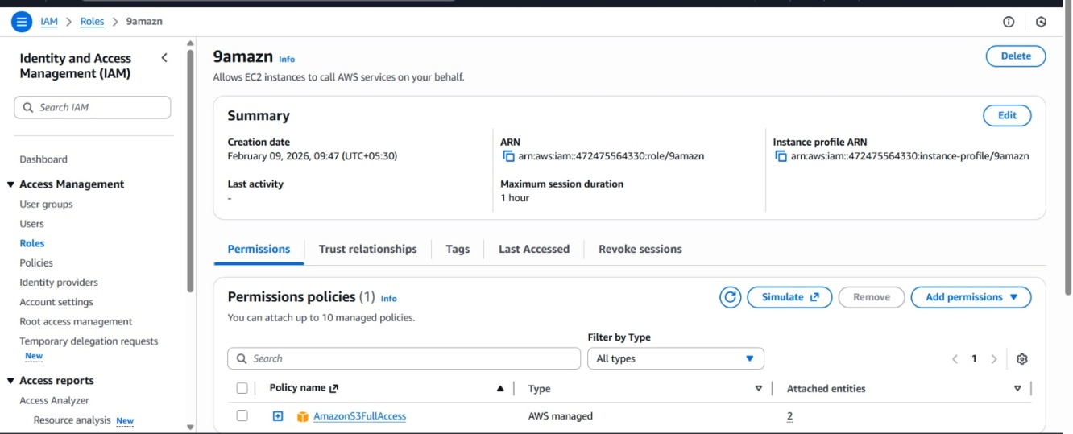

5.

Virtual Private Gateway in Cloud (AWS)
Vpc - subnet - route table - internet gateway

VPC = your cloud network
VGW = the secure gate
Customer Gateway = your office router
VPN = the tunnel between them

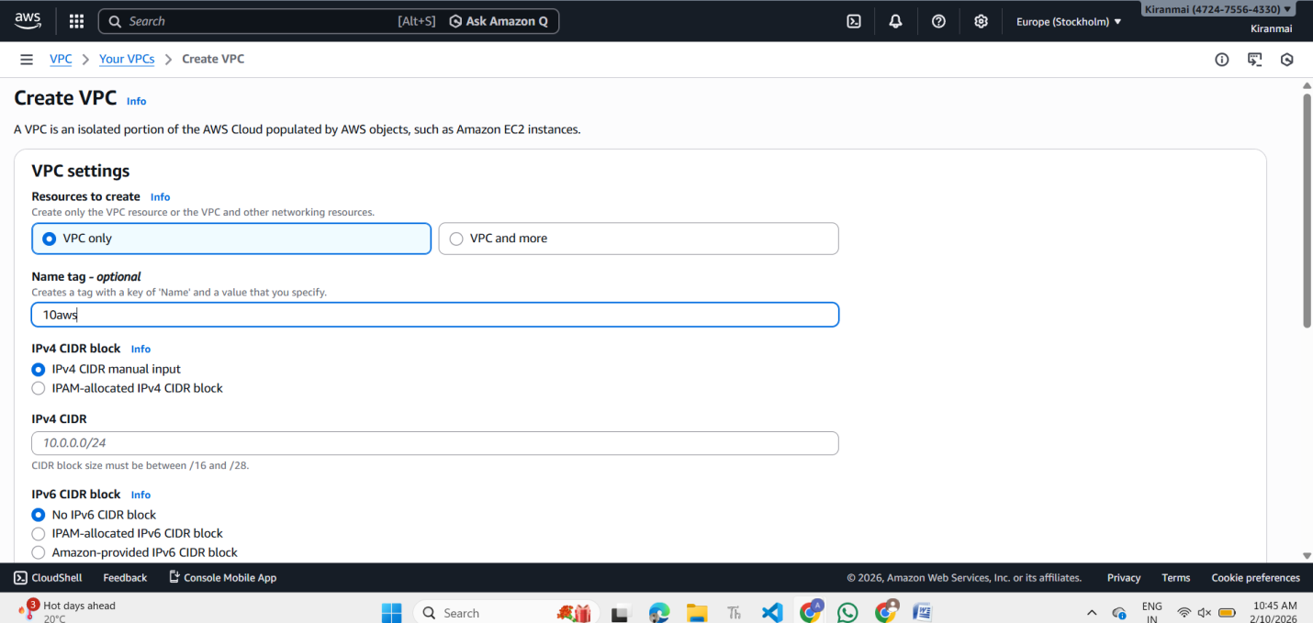

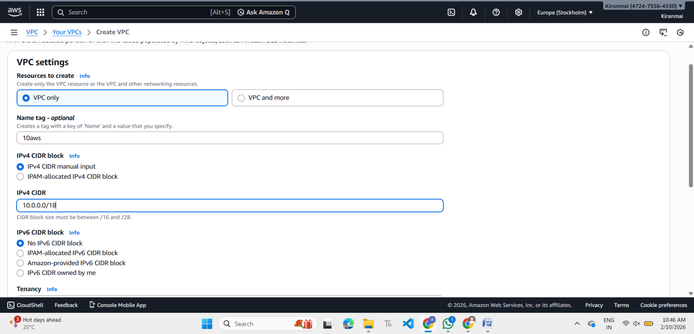

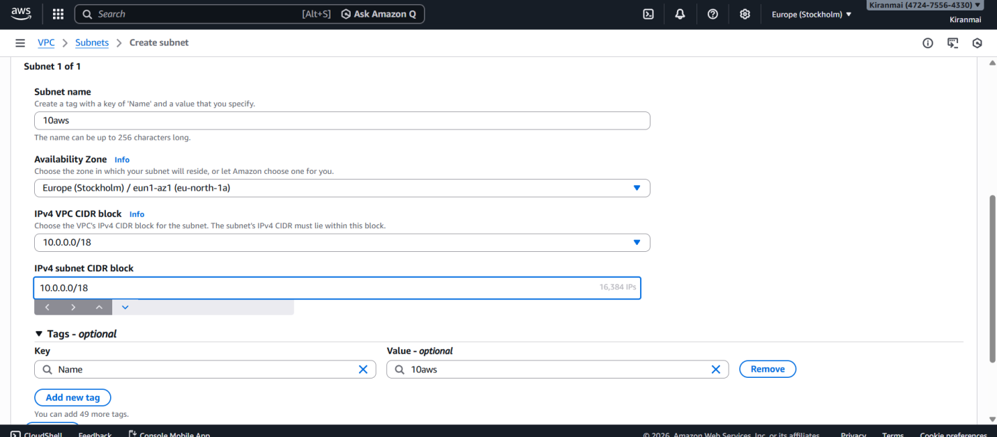

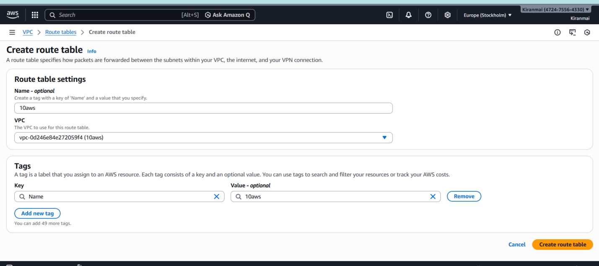

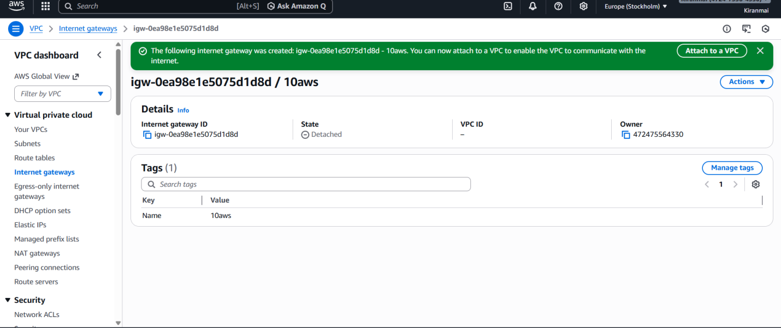

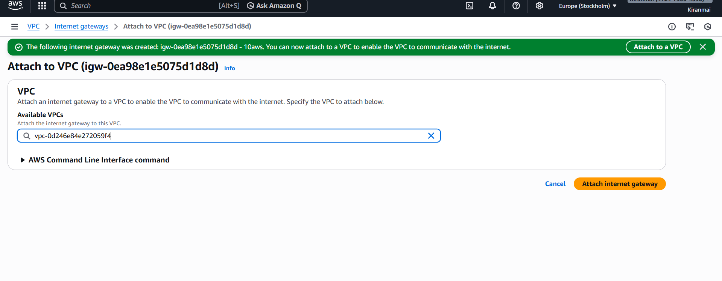

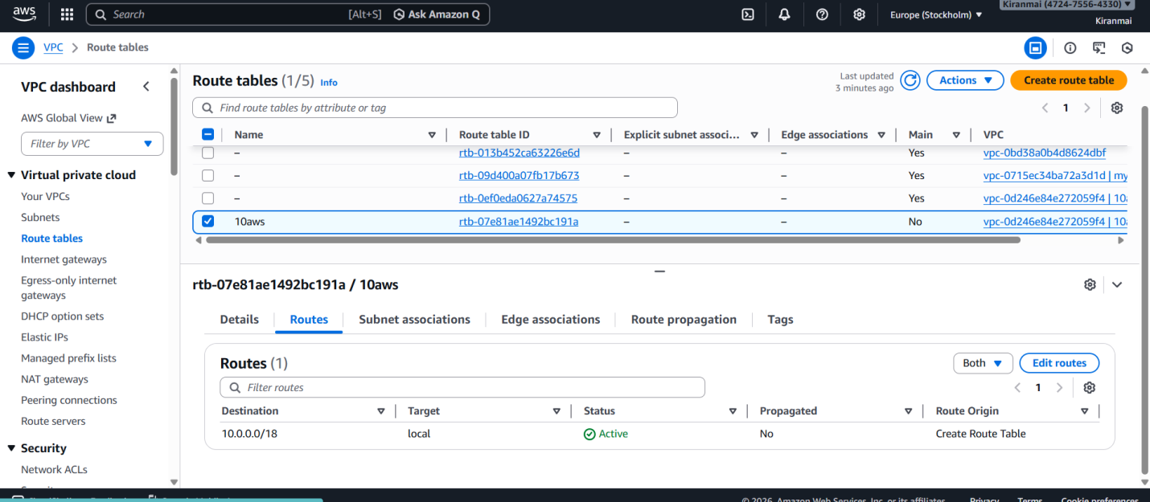

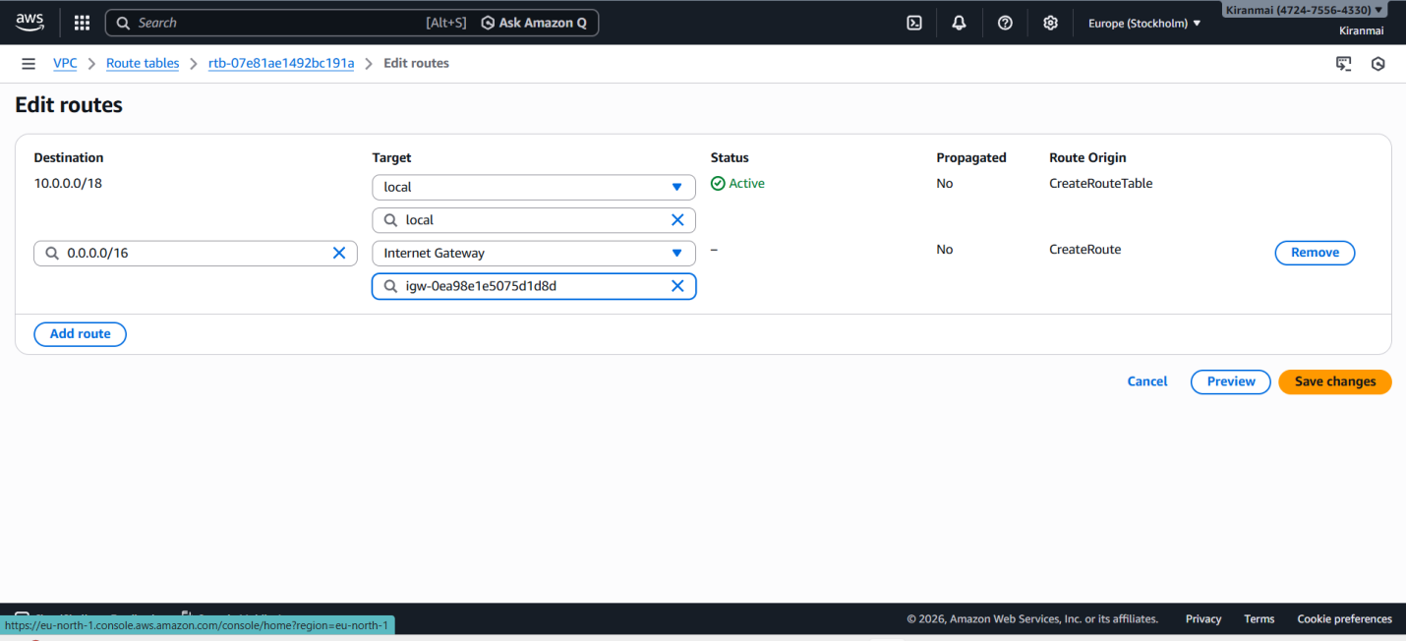

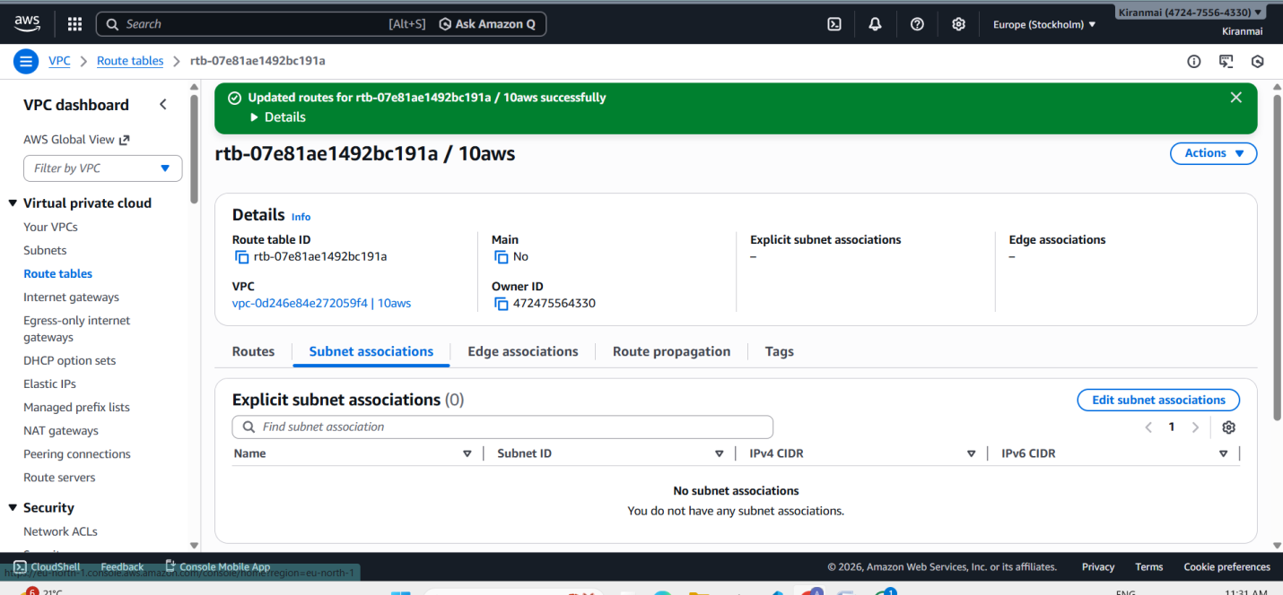

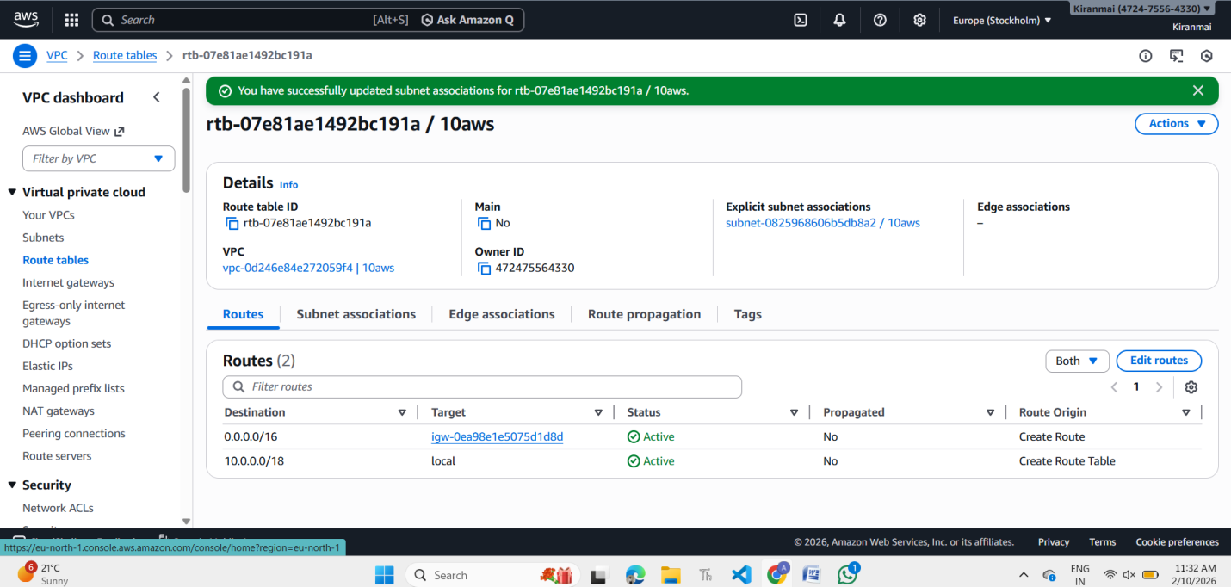

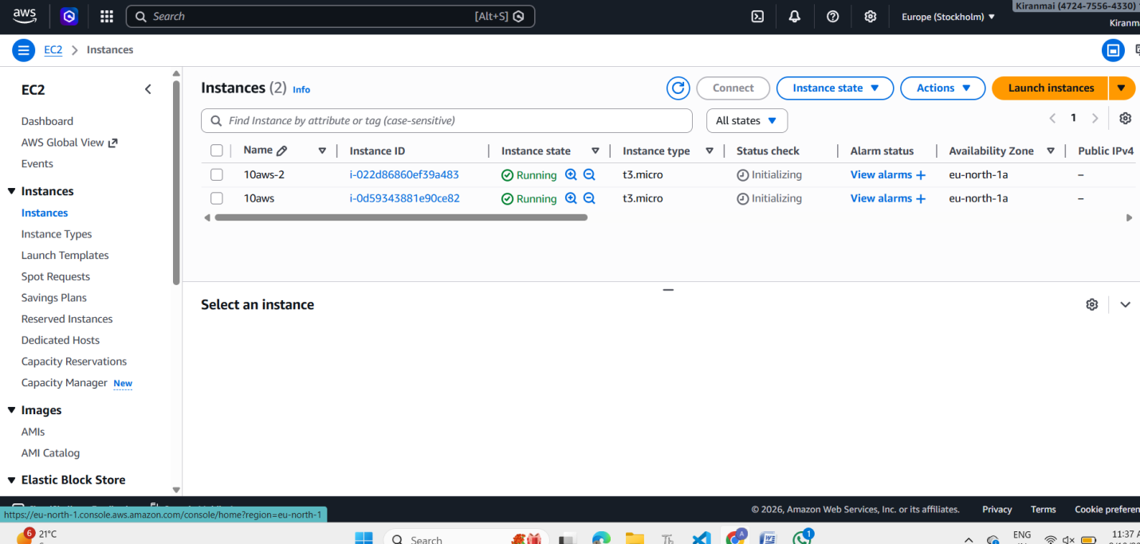

Windows
Linux
Use vpc also

6. vpc (peering vpc )

(PRACTICAL STEPS)

Step 1: Create VPC 1 (Public)
Go to:
AWS Console → VPC → Create VPC
Example:
- Name: Public-VPC
- CIDR: 10.0.0.0/16

Step 2: Create Subnet (Public)
Create subnet:
- CIDR: 10.0.1.0/24
Enable:
Auto-assign public IP

Step 3: Create Internet Gateway
- Create IGW
- Attach to Public-VPC

Step 4: Route Table for Public VPC
Edit routes:
Destination: 0.0.0.0/0
Target: Internet Gateway

Step 5: Create VPC 2 (Private)
Create:
- Name: Private-VPC
- CIDR: 192.168.0.0/16
Create subnet:
- 192.168.1.0/24
No internet gateway needed.

Step 6: Create VPC Peering
Go to:
VPC → Peering Connections → Create
Requester:
- Public-VPC
Accepter:
- Private-VPC
Then accept the request.

Step 7: Update Route Tables (Very Important)

In Public VPC Route Table
Add:
Destination: 192.168.0.0/16
Target: Peering Connection

In Private VPC Route Table
Add:
Destination: 10.0.0.0/16
Target: Peering Connection

Step 8: Launch EC2 in Both VPCs
Then test:
ping private-ip
If ping works → setup correct.

REAL-LIFE ANALOGY
Think like this:
- VPC = City
- Subnet = Area
- Route table = Roads
- Internet gateway = Highway to outside world
- Peering = Bridge between two cities

7. TGW (transit gateway)

Cloud solution architecture – wrking on clouds

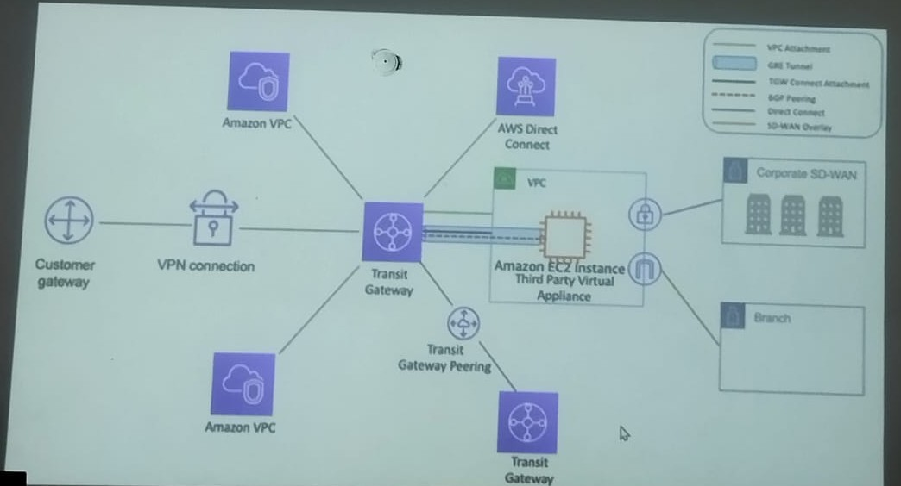

- VPC → A private network in AWS where servers run.
- Transit Gateway → A central router that connects multiple VPCs, VPNs, and offices.
- VPN Connection → Secure tunnel from company network to AWS over the internet.
- Customer Gateway → Your office or on-premise network.
- Direct Connect → Dedicated private line to AWS (faster than VPN).
- EC2 Virtual Appliance → Firewall or security device.
- Transit Gateway Peering → Connects gateways in different regions.
A Transit Gateway acts like a central hub to connect many VPCs and networks easily instead of connecting each one separately.

Implementation of AWS Transit Gateway

Transit Gateway is used to connect multiple VPCs in large applications so different parts of a system can communicate securely.

Step 1: Create VPCs
You created two VPCs.
Example:
- VPC-1 → 10.0.0.0/16
- VPC-2 → 192.168.0.0/16
Explanation:
A VPC (Virtual Private Cloud) is a private network in AWS where resources like EC2 run.

Step 2: Create Subnets
You created one subnet in each VPC.
Example:
- VPC-1 subnet → 10.0.1.0/24
- VPC-2 subnet → 192.168.1.0/24
Explanation:
A subnet divides a VPC into smaller networks and determines where EC2 instances are placed.
You asked:
Same AZ or different?
Answer:
- Same AZ is fine for practice
- Different AZ is used in real projects for high availability

Step 3: Create Transit Gateway
You created one Transit Gateway.
Explanation:
A Transit Gateway acts like a central router (hub) that connects multiple VPCs.
You asked:
Do we need two Transit Gateways?
Answer:
- No, one Transit Gateway is enough for multiple VPCs.

Step 4: Attach VPCs to Transit Gateway
You created two attachments:
- Attachment for VPC-1
- Attachment for VPC-2
Explanation:
Attachment means connecting a VPC to the Transit Gateway.
You asked:
Same name?
Answer:
- Names can be different; only the Transit Gateway must be the same.

Step 5: Route Tables
You used the default route tables created automatically by AWS.
You learned how to identify which route table belongs to which VPC by checking:
- VPC column
- Route table details
Then you added routes:
VPC-1 route table:
Destination: 192.168.0.0/16
Target: Transit Gateway
VPC-2 route table:
Destination: 10.0.0.0/16
Target: Transit Gateway
Explanation:
A route table decides where network traffic goes.
Without routes, VPCs cannot communicate.

Step 6: Launch EC2 Instances
You launched:
- One EC2 in VPC-1
- One EC2 in VPC-2
Security Group rules added:
- SSH
- All ICMP (for ping)
Explanation:
Security groups act like a firewall.
Ping works only if ICMP is allowed.

Step 7: SSH into EC2
You connected using:
ssh -i 12aws.pem ec2-user@Public-IP
First error:
Permission denied (publickey)
Reason:
- Wrong key name used
Then login succeeded with correct key.

Step 8: Test Communication
From EC2-VPC1:
ping Private-IP-of-EC2-VPC2
Explanation:
Ping checks if the network path is working.
Flow:
EC2 → Route Table → Transit Gateway → Route Table → EC2

VPC
Private network in AWS.
Subnet
Smaller network inside VPC.
Route Table
Rules that control traffic flow.
Transit Gateway
Central router connecting multiple VPCs.
Attachment
Connection between VPC and Transit Gateway.
Security Group
Firewall controlling instance traffic.

Cs, attached them to a Transit Gateway, updated route tables, launched EC2 instances, and verified connectivity using ping.”

VPC-1 → 10.0.0.0/16

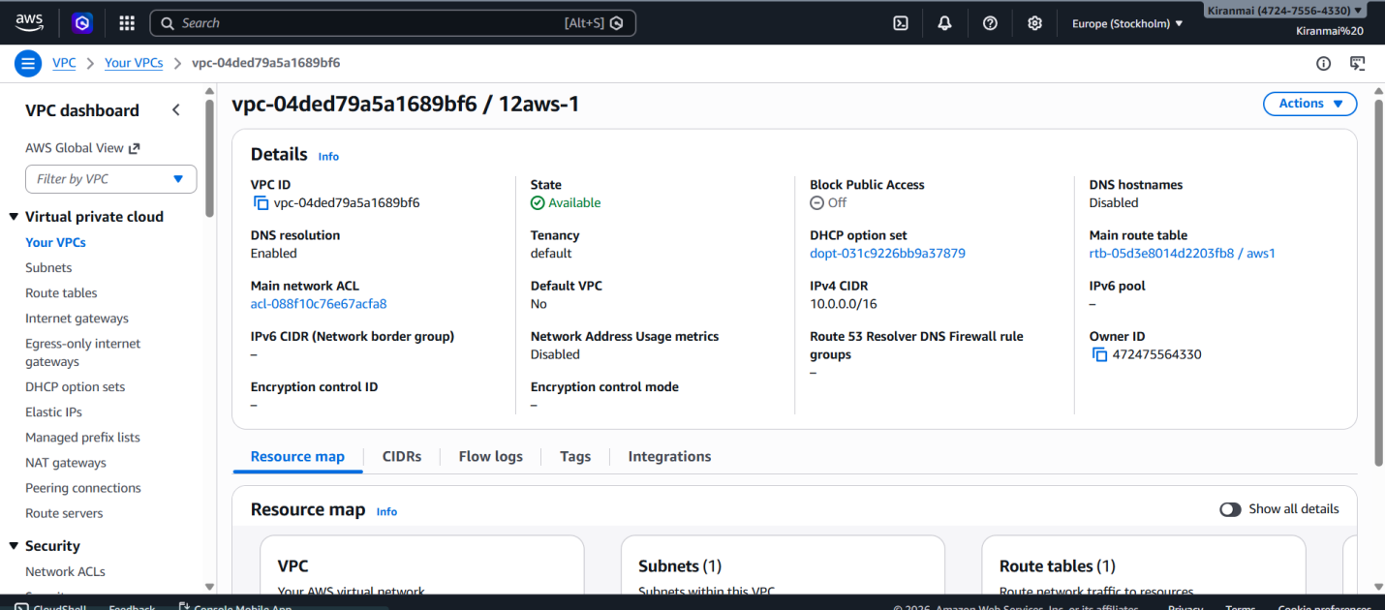

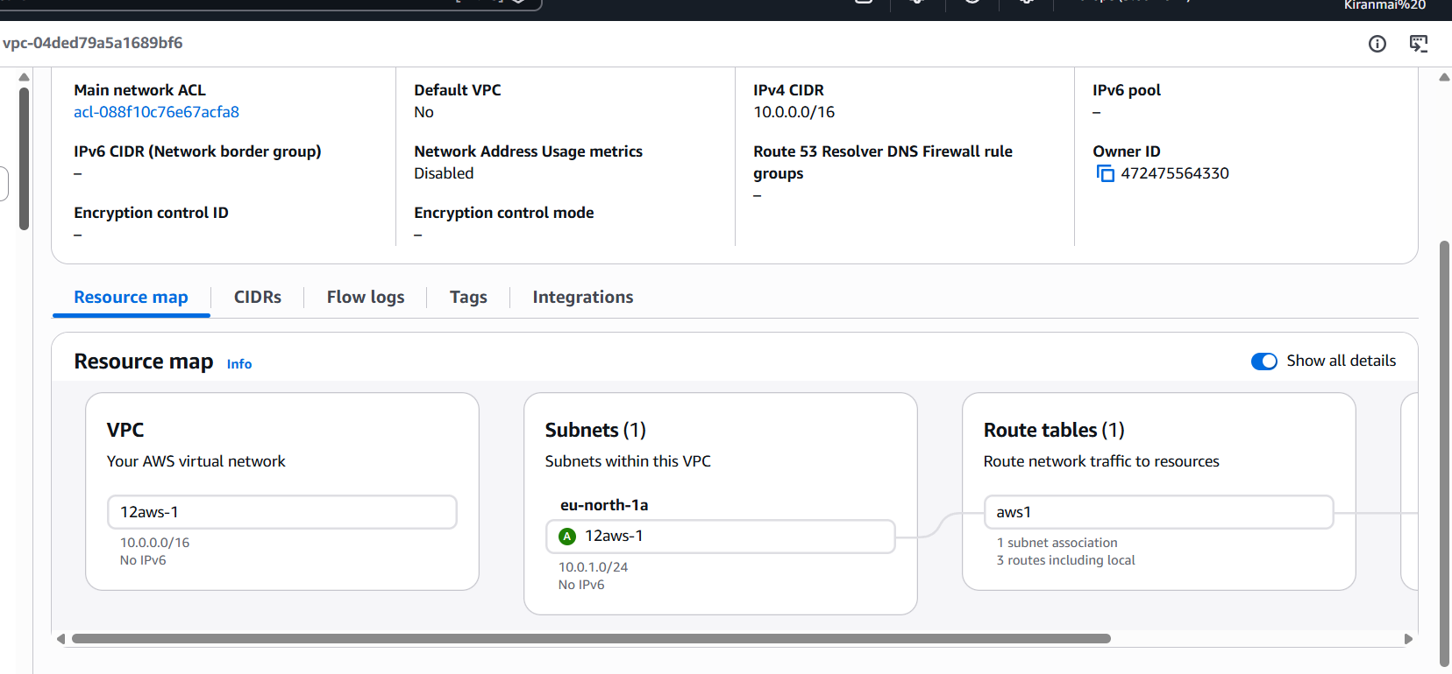

VPC – 2 192.168.0.0/16

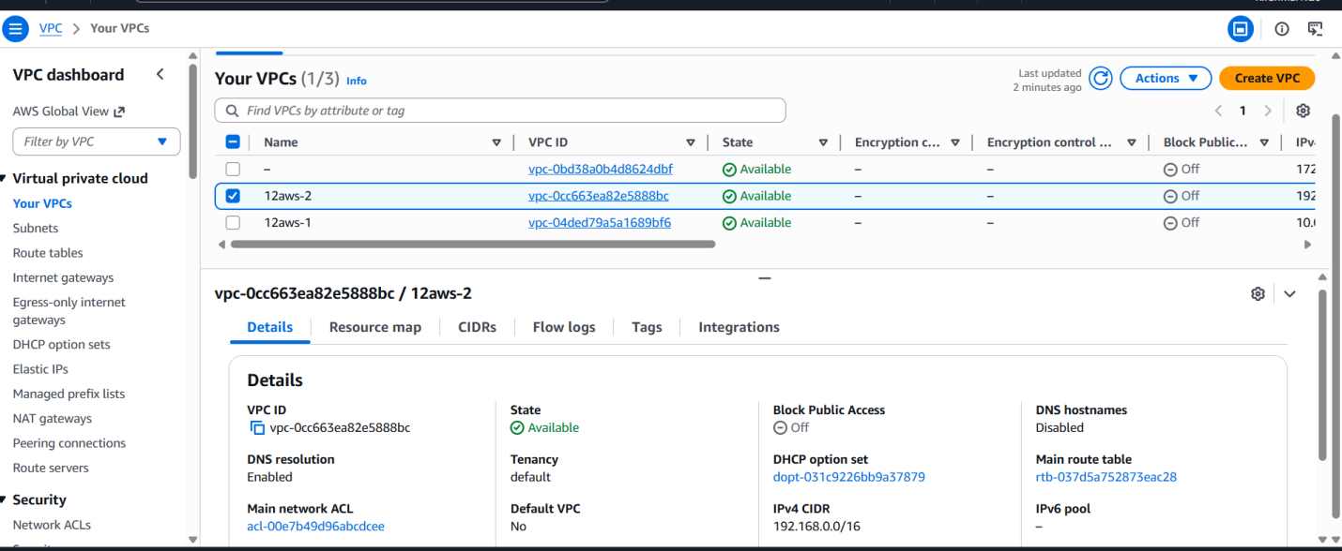

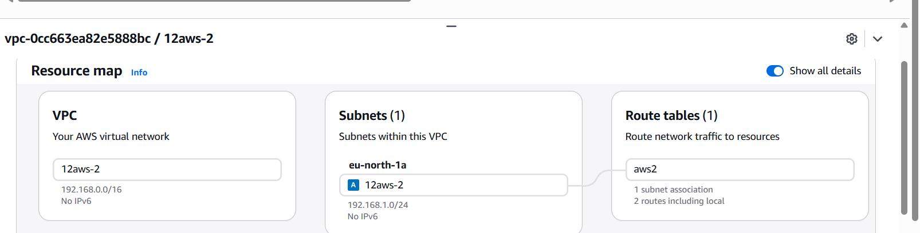

Subnet – 1

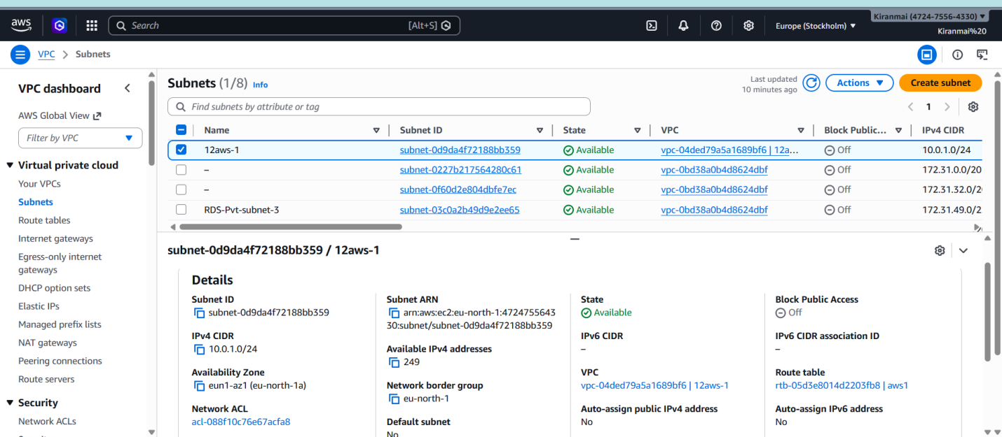

Subnet – 2

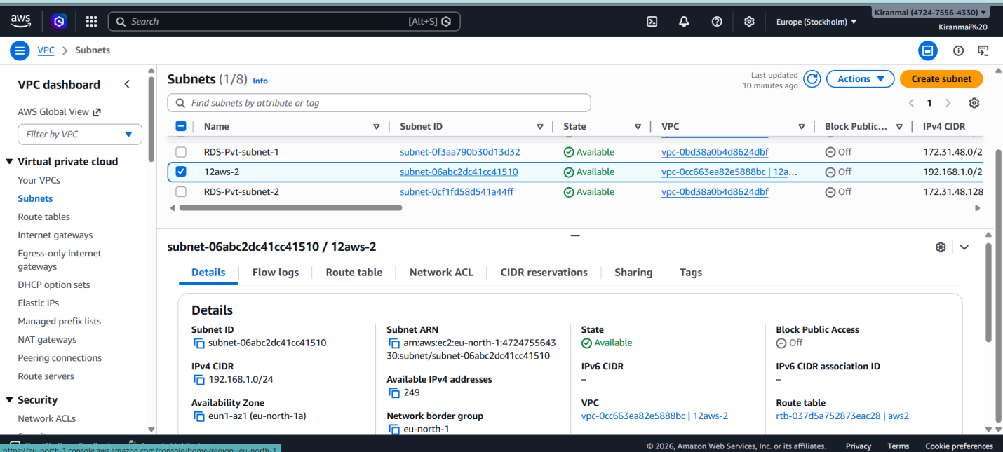

Route table (aws-2)
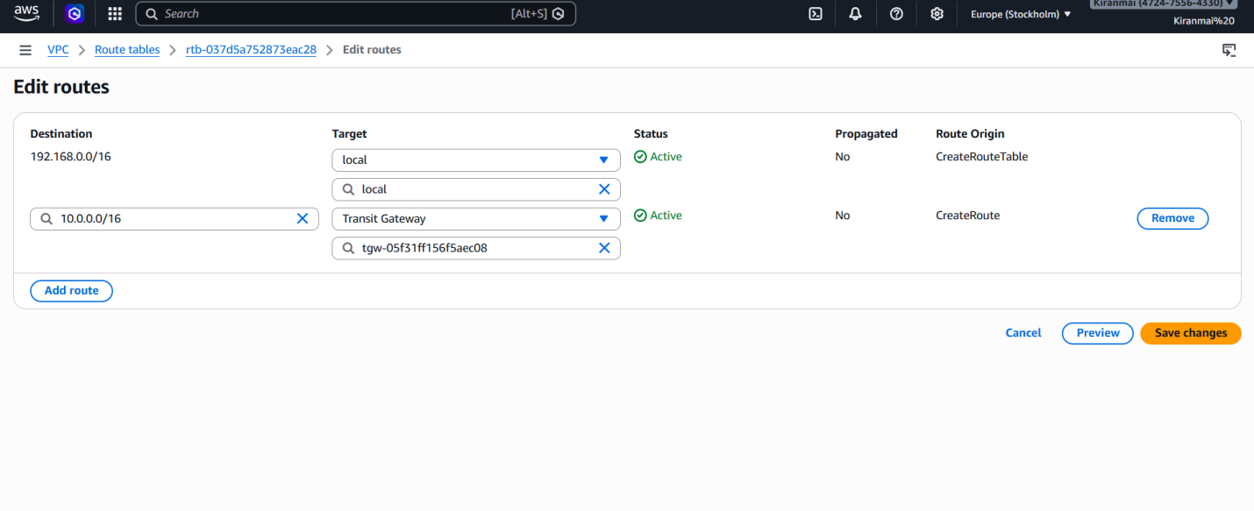

Aws – 1

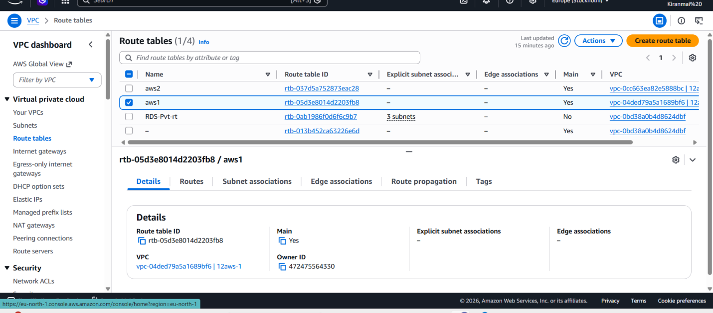

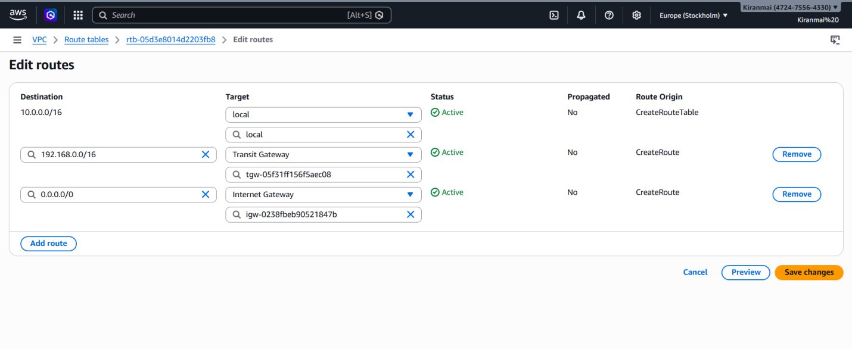

Internet gateway

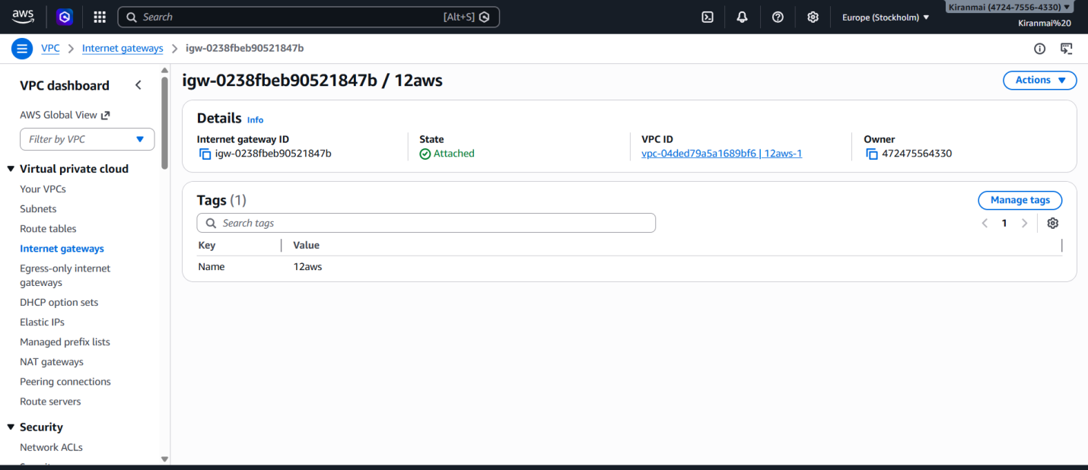

Transit gateway

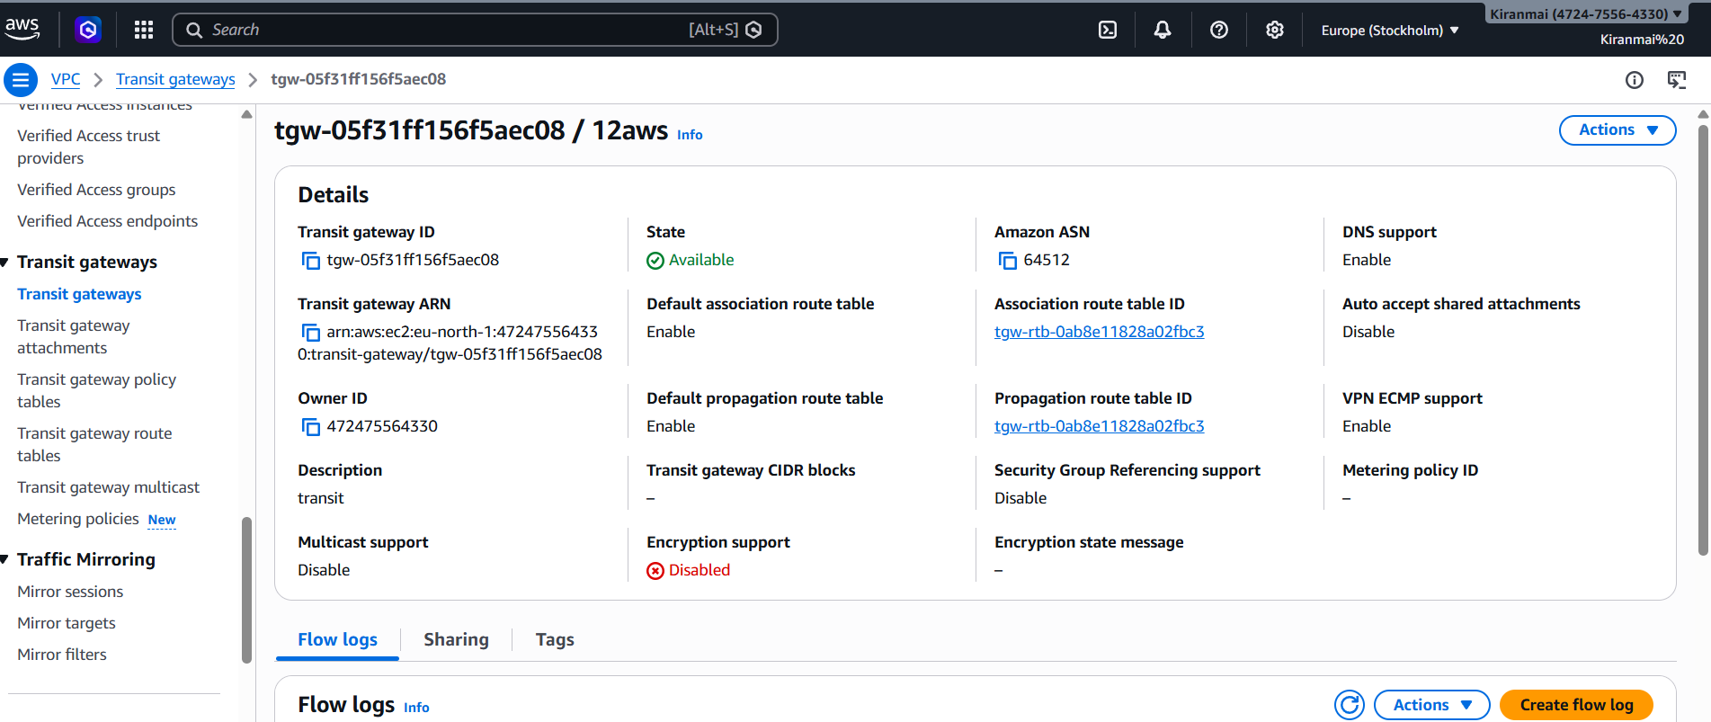

Transit gateway attachment (aws - 2)

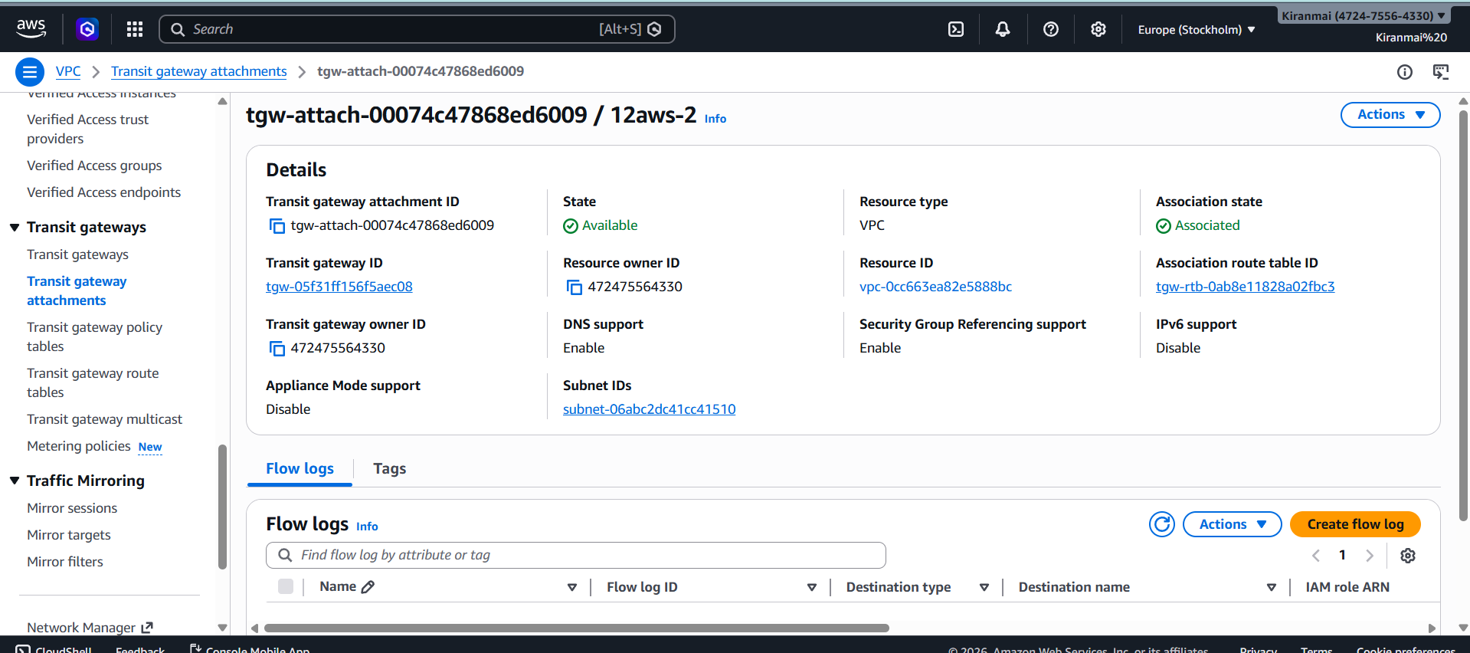

Transit gateway attachment (aws-1)

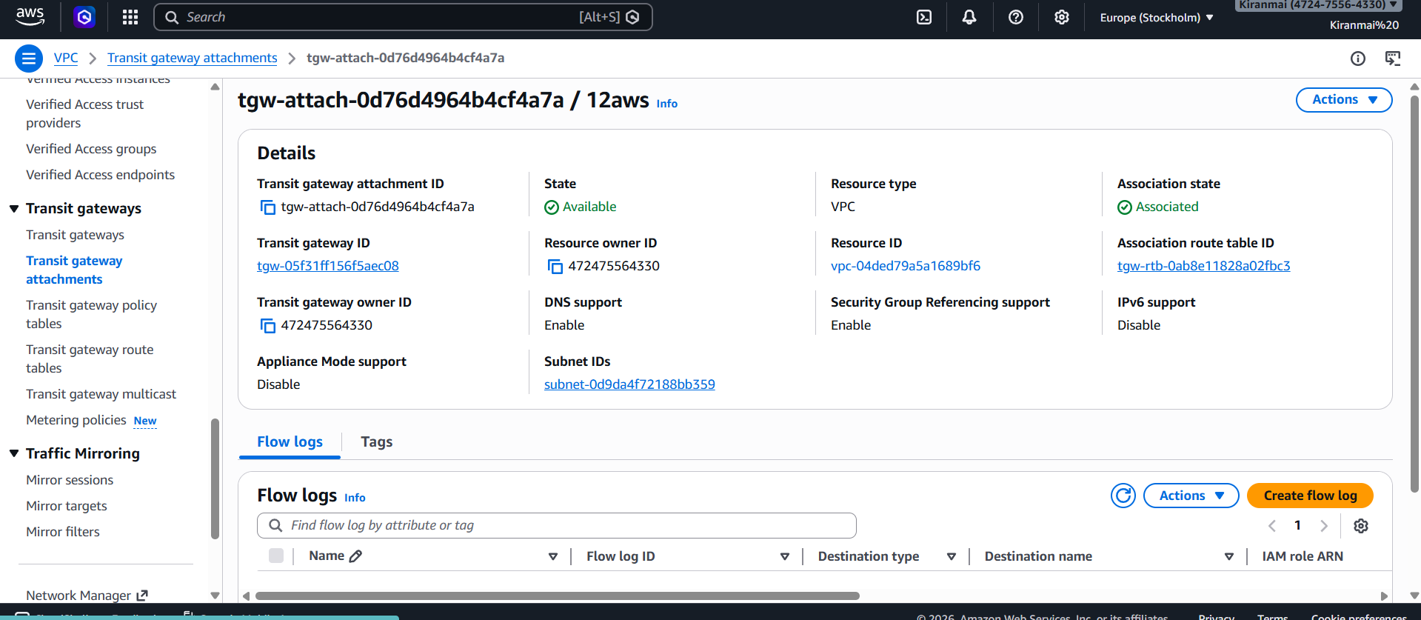

Instamce-1

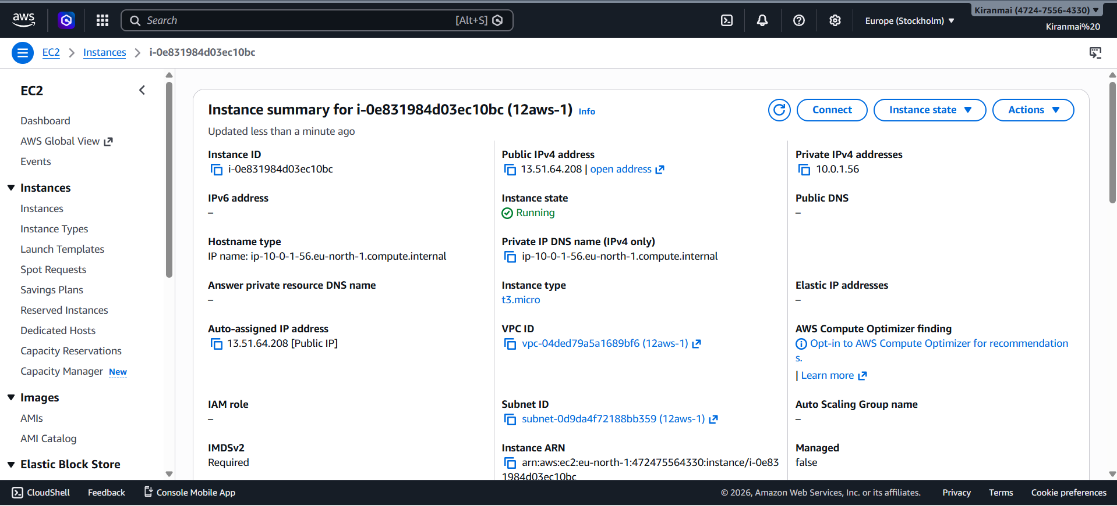

Instance – 2

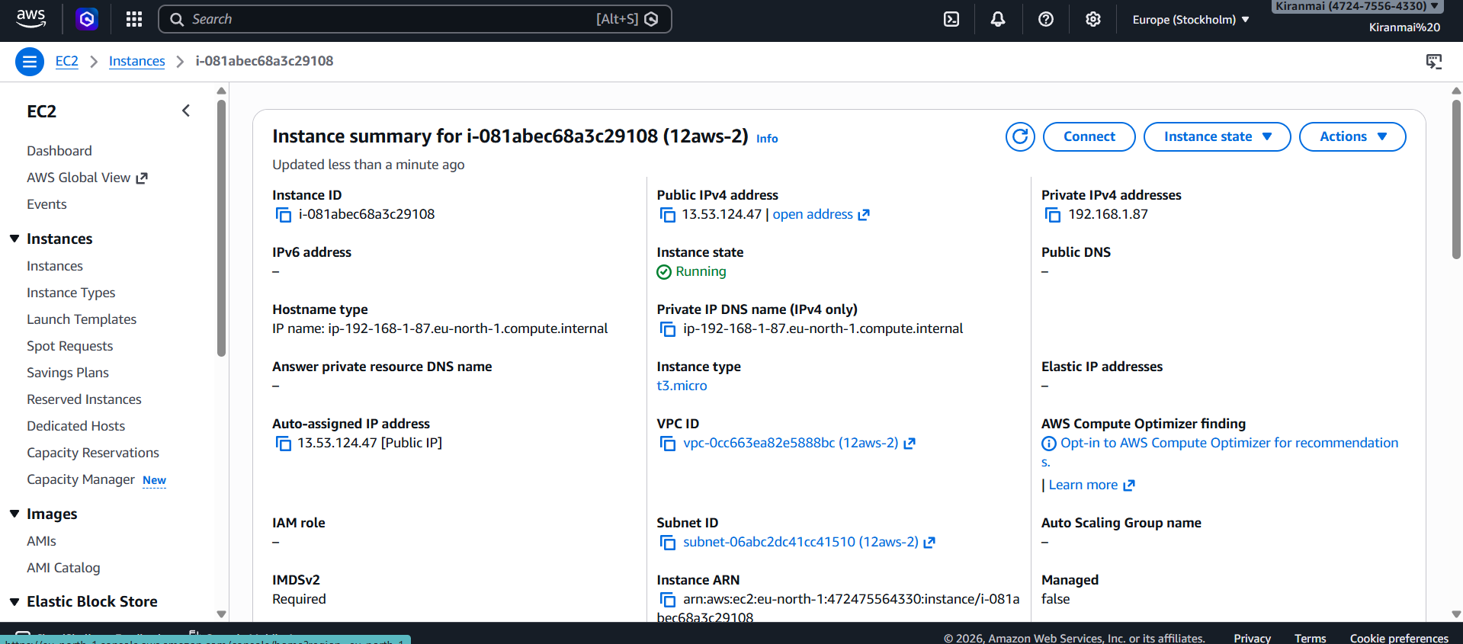

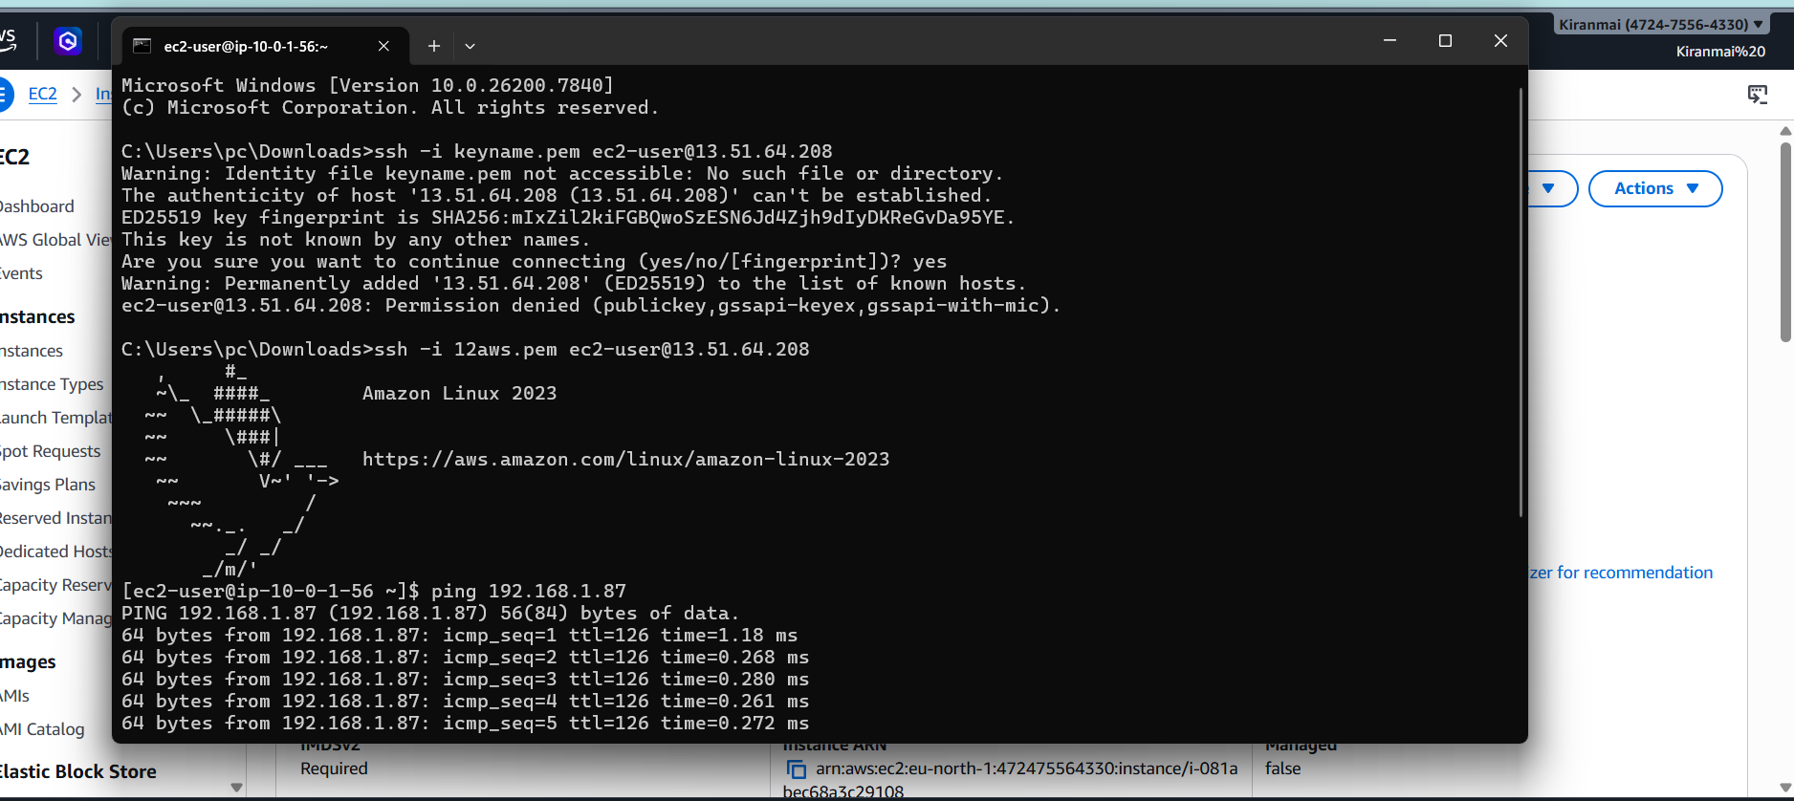

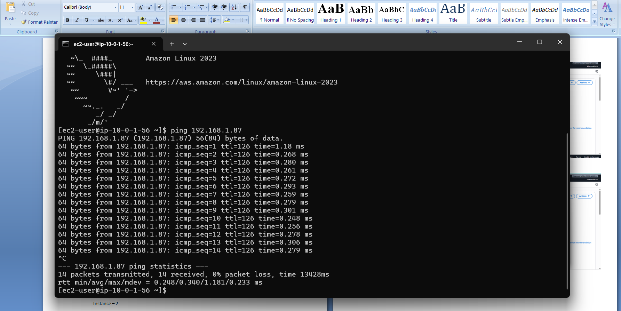
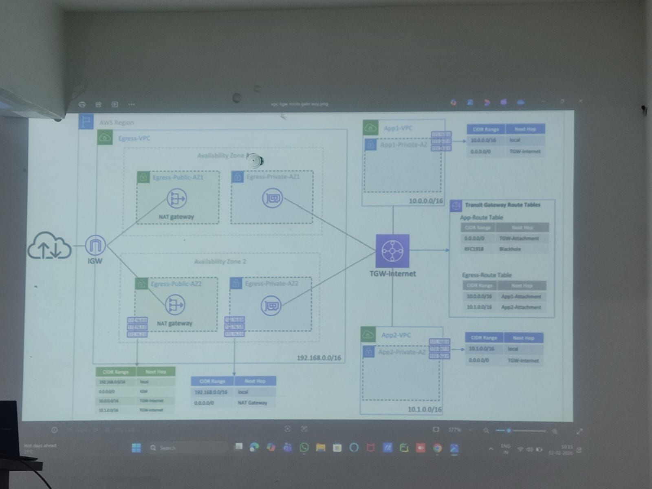

-----STEPS ------

Vpc1 ---- /16

Subnet1 --- same availability zone all 10.0.1.0/24 --- click add new subnet
Subnet 2 ---10.0.2.0 /24 subnet 3 --- 10.0.100.0/28
CREATE ALL SUBNETS

Internet gateway and attach vpc

Route table 1 --- connect vpc --- edit routes ( all zeros internet gateway)

Transit gateway (accept shared … )
Transit gateway route table
Gateway attachments --
Subnets – actions --- edit route acl associations -- (/16 transit gateway 2 routes changes same)
Subnet assoc -- edit – save

Gateway trnsit route --- actions --- create propagation

Elastic load balancer (beanstalk)

A load balancer receives user requests and distributes them to multiple servers in private subnets, while auto scaling adds or removes servers automatically to handle traffic and keep the app available.

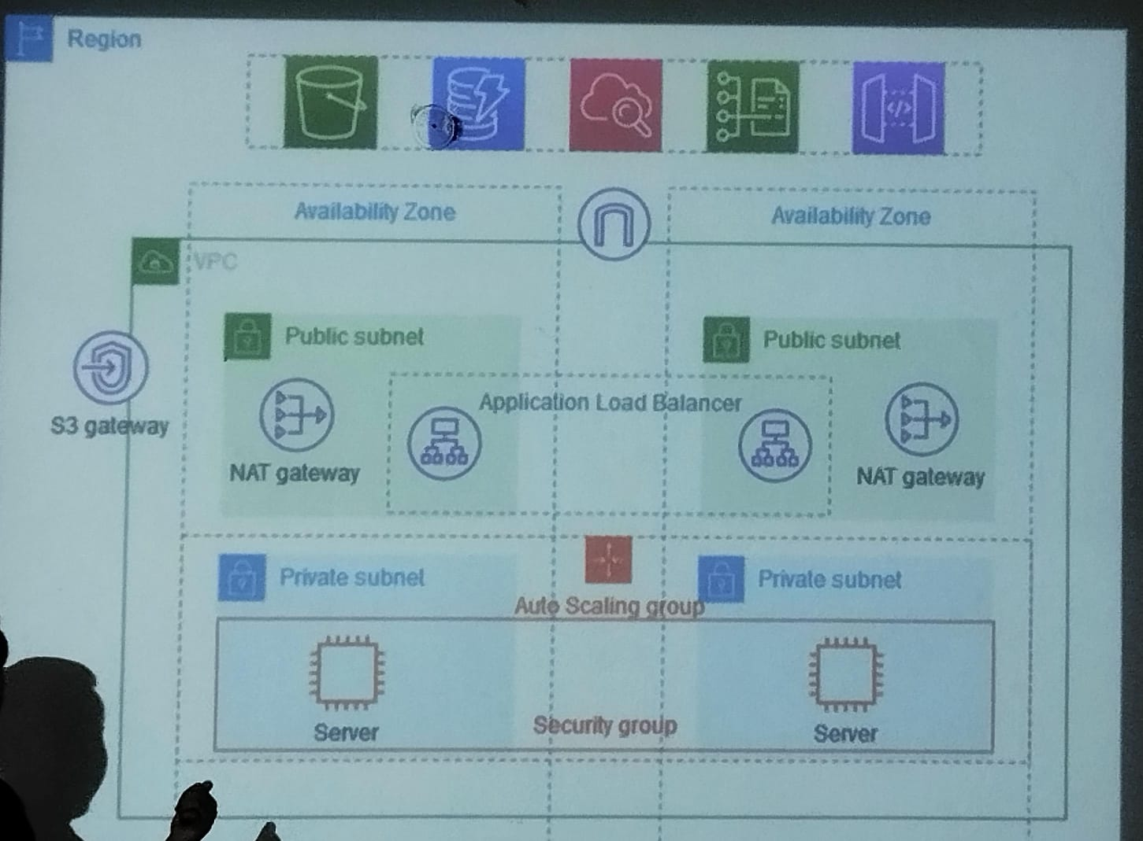

• Region – A geographical location where AWS data centers are located (for example, Mumbai).
• Availability Zone – A separate data center inside a region, used to keep applications running even if one zone fails.
• Amazon VPC – A private network in AWS where your resources (servers, databases, etc.) run securely.
• Public Subnet – A subnet that can connect directly to the internet; used for load balancers or gateways.
• Private Subnet – A subnet without direct internet access; used for application servers for better security.
• Application Load Balancer – Distributes incoming user requests across multiple servers to improve performance and reliability.
• NAT Gateway – Allows private servers to access the internet (for updates, downloads) without exposing them publicly.
• Amazon EC2 Auto Scaling – Automatically increases or decreases the number of servers based on traffic.
• Amazon EC2 (Server) – A virtual machine where your application runs.
• Security Group – A firewall that controls which traffic is allowed to reach the servers.
• Amazon S3 Gateway – A connection that allows resources in the VPC to access S3 storage privately.

PROCEDURE -----

• The application is deployed inside a Amazon VPC, which is the private network in AWS.
• The VPC is divided into two Availability Zones so that if one zone fails, the application still works from the other.
• Each Availability Zone contains a Public Subnet and a Private Subnet.
• Users from the internet send requests to the Application Load Balancer (DISTRIBUTES USER REQ TO SERVERES) located in the public subnet.
• The load balancer distributes the incoming traffic to multiple application servers running in private subnets.
• These servers are part of an Amazon EC2 Auto Scaling(ADDS OR REMOVES SERVERS BASED ON TRAFFIC) group, which automatically increases or decreases the number of servers based on traffic.
• The servers are protected by a Security Group, which allows only required traffic (mainly from the load balancer).
• If the servers need internet access (for updates or downloads), traffic goes through the NAT Gateway in the public subnet, so servers remain private.
• The application can also access storage through Amazon S3 using the S3 gateway without exposing data to the public internet.

